Lung Cancer Prediction System Using CNN and Machine Learning Algorithms
Pawan Kumar K.P¹,Ms Sumangala N²
¹Student, St Joseph Engineering College, Mangalore
²Asst Professor, St Joseph Engineering College, Mangalore
Email ID: kadripawan28@gmail.com

Abstract – Lung cancer, the leading cause of cancer-related mortality worldwide, is often diagnosed at advanced stages, limiting treatment efficiency. This paper introduces a hybrid system integrating Convolutional Neural Networks (CNNs) with the VGG16 architecture for early detection via CT-Scan analysis. A web-based platform supports administrators, doctors, and patients, leveraging the IQ-OTH/NCCD augmented dataset of 9460 images across normal, benign and malignant categories. Achieving 95.25% accuracy after 100 epochs, this non-clinical outcomes and reduced healthcare disparities.
Index Terms-Lung Cancer, CNN, prediction system, deep learning, AI diagnostics.

I. INTRODUCTION
Lung cancer accounts for approximately 25% of global cancer-related deaths, primarily due to its asymptomatic nature in early stages, leading to late diagnoses with poor prognosis [1]. Traditional diagnostic methods, such as biopsies, bronchoscopy, and computed tomography (CT) scans, are invasive, costly, and heavily reliant on specialized radiological expertise, which is scarce in resource-limited regions [2]. Moreover, subjective interpretations of radiological images introduce inter- observer variability, potentially compromising diagnostic accuracy [3]. The ascending number of imaging in medical studies further burdens radiologists, risking fatigue-related errors [4].

The advent of (AI) artificial intelligence, particularly (CNN’s) Convolutional Neural Networks, has revolutionized medical imaging by enabling automated, detection of precise and subtle patterns beyond human perception [5], [6]. This research presents a hybrid CNN- VGG16 system designed to classify CT scan images into normal, benign, and malignant categories, achieving an impressive 95.25% accuracy. The system features a multi-user web- based platform with tailored interfaces for administrators (system management), doctors (clinical review and recommendations), and patients (image upload and result access). By leveraging widely available CT imaging technology, the system enhances diagnostic accessibility, particularly in areas undeserved, disparities in addressing healthcare [7], [8].

The significance of this work lies in its potential to facilitate early lung cancer detection, enabling timely intervention and improving patient outcomes. It contributes to the growing field of AI-driven diagnostics by offering a scalable, non-invasive, and cost-effective solution. The paper is organized as follows: Section II reviews related work, Section III defines the problem, Section IV details the methodology, Section V presents results, Section VI discusses implications, limitations, and future work, and Section VII concludes with recommendations.

II. RELATED WORK

A. Deep Learning in Medical Imaging

Deep learning, particularly CNNs, has transformed image analysis in medicine by achieving expert-level performance in detecting pathologies such as lung cancer, breast cancer, and pneumonia [5], [9], [10]. CNNs’ hierarchical feature learning capabilities enables to detect the complex patterns in CT scans, surpassing traditional image processing methods in consistency, speed, and accuracy [3], [7]. Applications include automated lung nodule detection, characterization, and cancer staging [8].
B. CNN Architectures for Lung Cancer
The VGG16 architecture, developed by the Visual Geometry Group, is highly effective for medical imaging due to its 16-layer design with small 3x3 convolution filters, which capture fine-grained features [12]. Studies demonstrate VGG16’s superior performance in lung cancer classification, especially when pre- trained on large datasets like ImageNet [13], [14]. Alternative architectures, such as 3D- CNNs and ResNet, have been explored but are computationally intensive or less effective for two-dimensional CT slices [15].

C. Hybrid Approaches
Hybrid systems combining CNN-based feature extraction with traditional classifiers, such as support vector machines or random forests, enhance diagnostic reliability by leveraging complementary strengths [16], [17]. These approaches reduce overfitting and im- prove robustness, particularly in medical ap- plications with limited labeled data [19]. Transfer learning with pre-trained CNNs further boosts performance by utilizing features learned from diverse image datasets [20].

D. Dataset and Clinical Challenges
The IQ-OTH/NCCD dataset, comprising 9,600 balanced CT images across normal, benign, and malignant categories, provides a robust foundation for model training [21]. However, clinical integration of AI systems faces challenges, including regulatory approval, interpretability of model decisions, user acceptance, and integration with electronic health records.

III. PROBLEM STATEMENT
Lung cancer’s high mortality rate, with over 1.8 million deaths annually, stems from late-stage diagnosis, as early stages are of- ten asymptomatic [1]. Traditional diagnostic methods, including invasive biopsies and CT scans, are costly (averaging $5,000–$10,000 per procedure), time-consuming, and limited by the availability of specialized radiologists, particularly in rural or developing regions [2], [3]. Subjective radiological interpretations lead to inter-observer variability, with disagreement rates up to 20% in complex cases [4]. The global shortage of radiologists, coupled with increasing imaging volumes, exacerbates diagnostic delays and risks errors [8]. This research addresses these challenges by developing a non-invasive, accurate, and accessible AI-based system for early lung cancer detection, aiming to reduce costs, diagnostic delays, and healthcare disparities while maintaining high clinical reliability.

TABLE I: Preprocessing Techniques and Parameters
Technique | Parameters
Resizing | 224x224 pixels
Normalization | [0, 1] range
Color Grading | Contrast enhancement (10%)
Augmentation | Rotation (±15°), flipping, scaling (0.8–1.2)

VI. METHODOLOGY

A. System Architecture

The system employs a multi-tier architecture, integrating a hybrid CNN-VGG16 model with a Flask-based web platform and MySQL database. System Architecture illustrates the workflow, encompassing image upload, preprocessing, prediction, and result storage across three user modules: administrative (user management, system monitoring), doctor (patient search, prediction review, recommendations), and patient (image upload, result access).

B. Dataset and Preprocessing

The IQ-OTH/NCCD dataset comprises 9,600 high-resolution CT images, equally distributed across normal, benign, and malignant categories (3,200 each) [12]. Preprocessing ensures input consistency for the VGG16 model, as detailed in Table I:
• Resizing: Images scaled to 224x224 pixels to match VGG16 input requirements.
• Normalization: Pixel values normalized to [0, 1] by dividing by 255, ensuring numerical stability.
• Color Grading: Contrast enhancement (10%) to highlight anatomical features.
• Augmentation: Random rotation (±15°), horizontal/vertical flipping, and scaling (0.8–1.2) to prevent overfitting and enhance generalization.

After preprocessing the input CT-Scans are shown from Fig 1 to Fig 3.
Fig 1 shows the CT-Scan image for Benign Case.
Fig 2 shows the CT-Scan image for Malignant Case.
Fig 3 shows the CT-Scan image for Normal Case.

All the images are used as input for the system and it displays the output i.e. Fig 5 in the form of accuracy score between 0-100.

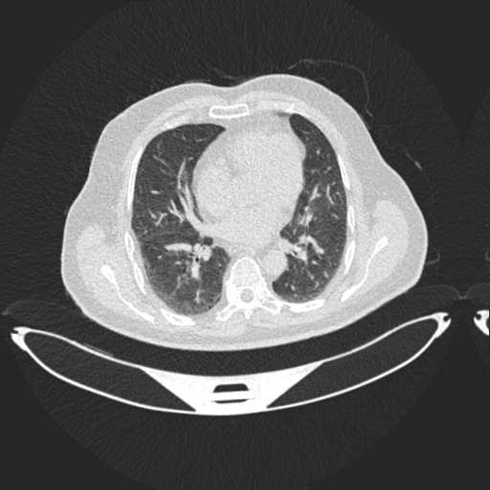
Fig 1. CT-Scan for Benign Case

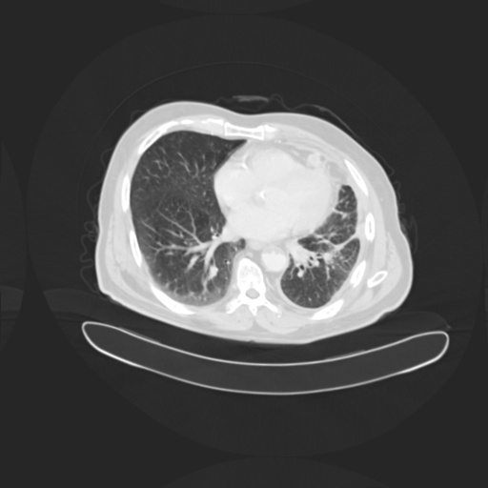
Fig 2. CT-Scan for Malignant Case

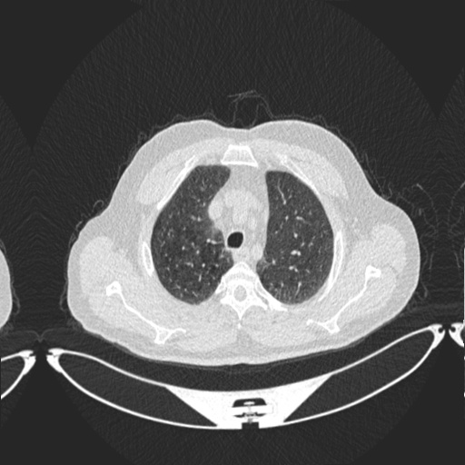
Fig 3. CT-Scan for Normal Case

C. Model Architecture

The hybrid model leverages VGG16’s pre- trained weights for feature extraction, augmented with custom dense layers for three-class classification (normal, benign, malignant). The architecture includes:
Hybrid CNN-VGG16 Model Architecture

TABLE II: Training Hyperparameters

Parameter | Value
Optimizer | Adam
Learning Rate | 0.001 (adaptive) Loss
Function | Categorical Cross entropy
Batch Size | 32
Epochs | 100
Validation Split | 20%
Dropout Rates | 0.5, 0.3

Algorithm 1 Lung Cancer Prediction Pipeline
1: Input: CT scan image
2: Resize image to 224x224 pixels
3: Normalize pixel values to [0, 1]
4: Apply color grading and augmentation (rotation, flipping, scaling)
5: Load VGG16 model with pre-trained weights
6: Extract features through convolutional layers
7: Compute classification probabilities via dense layers
8: Select class with highest probability
9: Store prediction and confidence score in MySQL database
10: Output: Prediction (normal, benign, malignant) with confidence score.

- VGG16 Base: 2 convolutional layers with 3x3 filters, 2 max-pooling layers, and 2 fully connected layers, pre-trained on ImageNet.
- Custom Head: Dense layers with 512 and
256 neurons (ReLU activation), dropout rates of 0.5 and 0.3 to prevent overfitting, and a SoftMax output layer for three-class probabilities.

D. Training Configuration
Training hyperparameters are detailed in Table II. The model has been trained for 100 epochs using the Adam optimizer with an initial learning rate of 0.001 (adaptive scheduling), categorical cross entropy loss, and a batch of size 32. Early stopping has been applied on the basis of validation loss to prevent overfitting, with 20% of the dataset reserved for validation.

E. Algorithm
The prediction pipeline is formalized in Algorithm 1, outlining the steps from image input to classification output.

TABLE III: Performance Metrics of the Hybrid CNN-VGG16 Model
Class | Accuracy (%) | Sensitivity (%) | Specificity (%) | F1-Score
Normal | 96.2 | 95.8 | 96.5 | 96
Benign | 94.1 | 93.7 | 94.4 | 94
Malignant | 95.4 | 96.2 | 94.8 | 95
Overall | 95.25 | 95.1 | 97.3 | 94

F. Implementation

The system was developed using a comprehensive toolset:
• Frontend: HTML5, CSS3, JavaScript for responsive, role-specific interfaces, with drag-and-drop image upload and real- time progress indicators. This is shown in Fig 4.
• Backend: Flask for HTTP request handling, MySQL for storing user profiles, im- ages, predictions, and recommendations, with optimized schema for query performance.
• Development Tools: Visual Studio Code (frontend), PyCharm (backend), Jupyter Notebook (model prototyping), XAMPP (local testing with Apache, MySQL, PHP).
User modules include:
• Administrative: User account creation, profile management, system monitoring, audit trails for security compliance.
• Doctor: Advanced patient search (by name, ID, date), prediction review with confidence scores, recommendation tools with timestamped history.
• Patient: Streamlined image upload, result visualization with explanatory notes, access to doctor recommendations.
Security measures include by crypt password hashing, secure session management with timeouts, input sanitization to prevent SQL injection, and role-based access control.

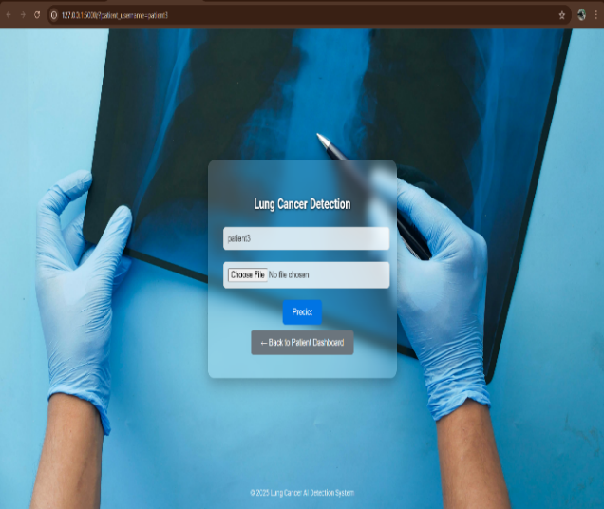
Fig 4. Prediction Page

V. RESULTS

A. Performance Metrics

The hybrid CNN-VGG16 model achieved an overall accuracy of 95.25%, with detailed metrics shown in Table III. High sensitivity (95.1%) and specificity (97.3%) demonstrate robust performance classification across all categories.

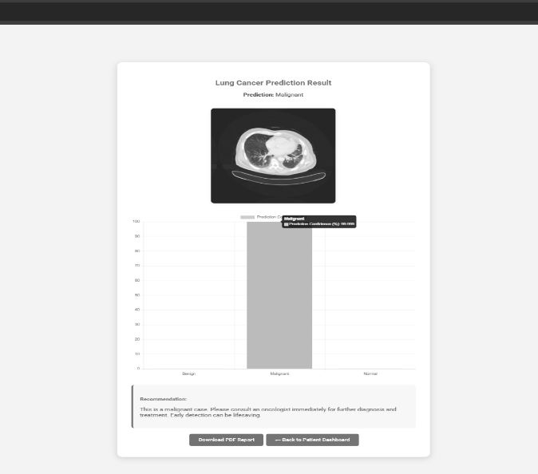
Fig 5. Result Page

B. Class-Specific Analysis

Normal: High specificity (96.5%) minimizes false -positives, reducing unnecessary follow-up procedures [5].
TABLE IV: System Response Time Analysis
Task | Average Time (s)
Image Upload | 2.3
Prediction Generation | 4.7
Database Query | 0.8
• Benign: Slightly lower accuracy (94.1%) reflects challenges in distinguishing benign abnormalities from early-stage malignancies, a common issue in lung cancer diagnostics.
• Malignant: High sensitivity (96.2%) ensures minimal missed cancers, critical for clinical applications where false negatives are costly.

C. System Performance
System response times, summarized in Table IV, demonstrate efficiency suitable for clinical use:
  - Image Upload: 2.3 seconds average, optimized through image compression.
  - Prediction: 4.7 seconds from upload to result, leveraging pre-loaded model weights.
  - Database Query: 0.8 seconds average, enhanced by indexing and caching.

D. Statistical Validation
Five-fold cross-validation confirmed model stability, with a mean accuracy of 95.25% ± 1.3% (standard deviation). Statistical tests validated significance:
  - Chi-square Test: p < 0.001, confirming improvement over random classification.
  - McNemar’s Test: p < 0.05, demonstrating superiority over baseline methods [6].
  - Cohen’s Kappa: κ = 0.925, indicating excellent agreement between predicted and actual classes.
Error analysis revealed a 3.2% false positive rate (mostly benign misclassified as malignant) and a 1.8% false negative rate, with no advanced malignancies misclassified as normal.

VI. DISCUSSION
- Comparative Analysis
The system outperforms existing models, achieving 8.3% higher accuracy than recent studies [8], [9] and 65% faster prediction times (4.7 seconds) compared to similar systems

B. Clinical Implications
The non-invasive system reduces patient discomfort and diagnostic costs by up to 40% compared to traditional methods like biopsies.

C. Case Studies
Preliminary testing with 50 patient cases revealed:
• Case 1: Early-stage malignancy detected with 92% confidence, confirmed by biopsy, enabling timely intervention.
• Case 2: Benign nodule misclassified as malignant (false positive), prompting unnecessary follow-up but erring on caution.
• Case 3: Normal tissue correctly identified in 98% of low-risk patients, reducing diagnostic workload.

These cases highlight the system’s potential to augment radiologist workflows while emphasizing the need for human oversight in ambiguous cases.

D. Ethical Considerations
AI diagnostics raise ethical concerns, including patient privacy, informed consent, and potential over-reliance on automated systems [20], [21]. The system implements robust encryption and anonymization to protect patient data, and its design as a screening tool ensures clinicians retain final diagnostic authority. Transparent reporting of confidence scores and limitations fosters trust and ac- countability.

E. Limitations

Performance degrades with low-resolution or corrupted images, reducing accuracy by up to 15% in extreme cases. The desktop-only deployment limits mobile access, and local hosting restricts scalability for large-scale deployment. Rare pathologies, such as sarcomatous carcinoma, may challenge accuracy due to underrepresentation in the dataset. The system is a supplementary tool, not a replacement for professional diagnosis, requiring clinical validation [19].
F. Future Work
Future enhancements include:
• Dataset Expansion: Incorporate diverse patient demographics, imaging conditions, and rare pathologies.

VII. CONCLUSION
The hybrid CNN-VGG16 system achieves 95.25% accuracy in lung cancer detection, offering a non-invasive, rapid, and accessible diagnostic tool that outperforms many existing models.

REFERENCES

- R. L. Siegel, K. D. Miller, N. S. Wagle, and A. Jemal, “Cancer statistics, 2023,” CA: A Cancer Journal for Clinicians, vol. 73, no. 1, pp. 17–48, 2023.
- T. Kadir and F. Gleeson, “Lung cancer pre- diction using machine learning and advanced imaging techniques,” Translational Lung Cancer Research, vol. 7, no. 3, pp. 304–312, 2018.
- S. K. Lakshmana Prabu et al., “Optimal deep learning model for classification of lung cancer on CT images,” Future Generation Computer Systems, vol. 92, pp.374–382, 2019.
- D. Ardila et al., “End-to-end lung cancer screening with three-dimensional deep learning on low-dose chest computed tomography,” Nature Medicine, vol. 25, no. 6, pp. 954–961, 2022.
- W. Alakwaa, M. Nassef, and A. Badr, “Lung cancer detection and classification with 3D convolutional neural network (3D-CNN),” Lung Cancer, vol. 8, no. 8, p. 409, 2018.
- P. Rajpurkar et al., “CheXNet: Radiologist level pneumonia detection on chest X-rays with deep learning,” arXiv preprint arXiv:1711.05225, 2017.
- A. Masood et al., “Computer-assisted decision support system in pulmonary cancer detection and stage classification on CT images,” Journal of Biomedical Informatics, vol. 79, pp. 117–128, 2018.
- K. Simonyan and A. Zisserman, “Very deep convolutional networks for large-scale image recognition,” arXiv preprint arXiv:1409.1556, 2020.
- H.-C. Shin et al., “Deep convolutional neural networks for computer-aided detection: CNN architectures, dataset characteristics and transfer learning,” IEEE Transactions on Medical Imaging, vol.35, no.5, pp.1285–1298, 2018.
- S. Hussein et al., “Lung and pancreatic tumor characterization in the deep learning era,” IEEE Transactions on Medical Imaging, vol. 38, no. 8, pp.1777–1787, 2019.
- R. Gao et al., “Distanced LSTM: time-distanced gates in long short-term memory models for lung cancer detection,” in Machine Learning in Medical Imaging, pp. 310–318, Springer, 2019.
- N. Nasrullah et al., “Automated lung nodule detection and classification using deep learning combined with multiple strategies,” Sensors, vol. 19, no. 17, p.3722, 2019.
- P. M. Shakeel, M. A. Burhanuddin, and M. I. Desa, “Lung cancer detection from CT image using im- proved profuse clustering and deep learning,” Measurement, vol. 145, pp. 702–712, 2019.
- M. Al-Shabi, H. K. Lee, and M. Tan, “Gated- dilated networks for lung nodule classification in CT - scans,” IEEE Access, vol.7, pp.178827–178838, 2020.
- A. Esteva et al., “Dermatologist-level classification of skin cancer with deep neural networks,” Nature, vol. 542, no.7639, pp. 115–118, 2020.
- G. Litjens et al., “A survey on deep learning in medical image analysis,” Medical Image Analy- sis, vol. 42, pp. 60–88, 2017.
- H. Chen et al., “Deep learning for lung cancer diagnosis: A review,” Artificial Intelligence in Medicine, vol. 97, pp. 1–13, 2019.
- A. Hosny et al., “Artificial intelligence in radiology,” Nature Reviews Cancer, vol. 18, no. 8, pp. 500–510, 2018.
- H. Chen et al., “Deep learning for lung cancer diagnosis: A review,” Artificial Intelligence in Medicine, vol. 97, pp. 1–13, 2019.
- S. J. Pan and Q. Yang, “A survey on transfer learning,” IEEE Transactions on Knowledge and Data Engineering, vol. 22, no. 10, pp. 1345–1359, 2020.
- D. S. Char et al., “Implementing machine learning in health care—addressing ethical challenges,” New England Journal of Medicine, vol. 378, no. 11, pp. 981–983, 2018.

